The below steps need to be followed once the Payroll processing date is in June 2020:

Step 1:

Click on **Payroll**

Click on **Definitions**

Select the **Methods of Calculation**

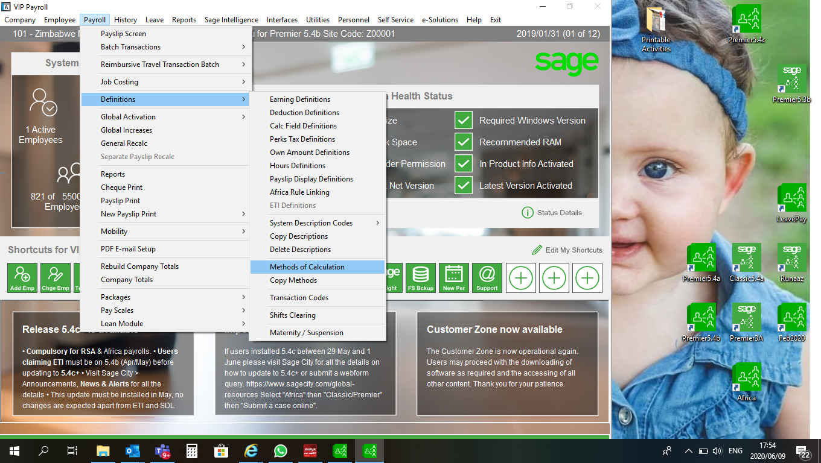

Step 2:

Click on **Change**

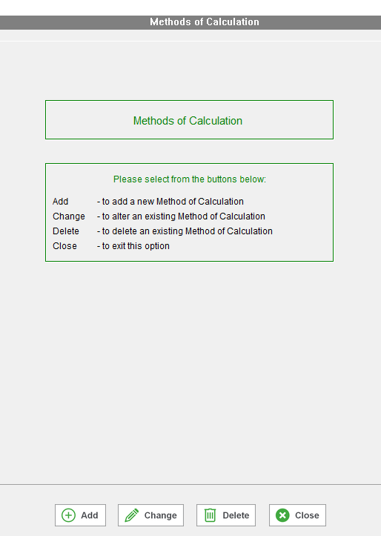

Step 3:

Click on your NSSA Deduction line and select method number 2

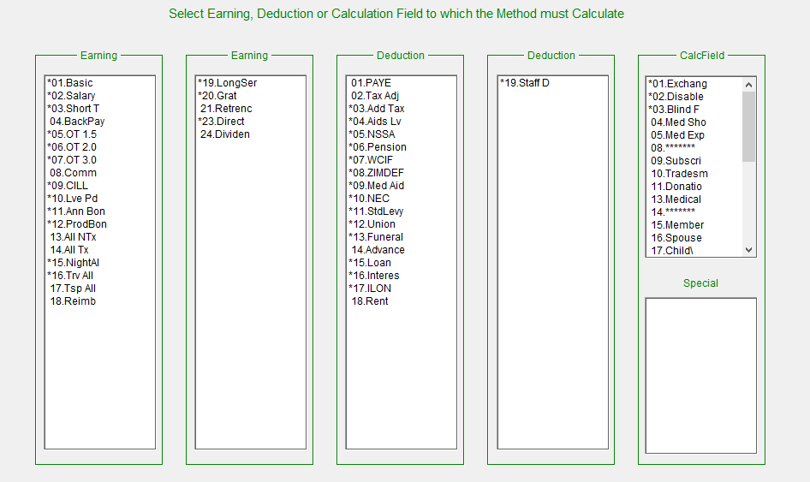 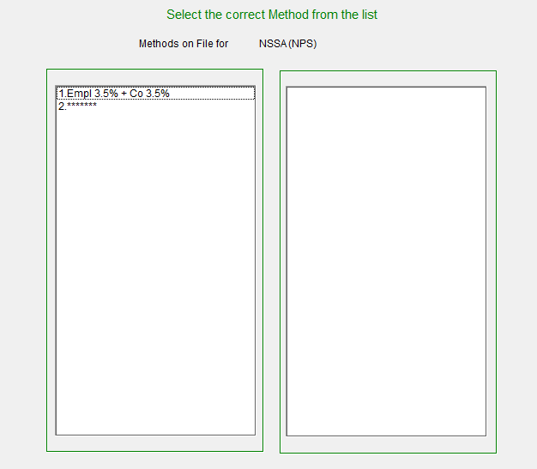

Step 4:

Change the contribution rate and increase the limits as indicated in the below method

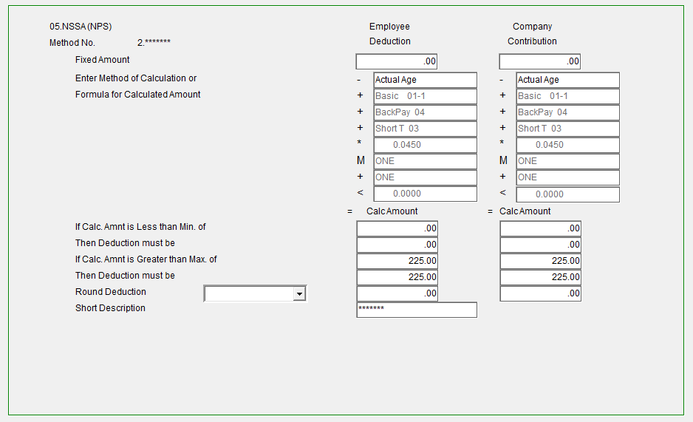

Step 5:

Once you are done, close the method screen and select YES to recalculate.

**Remember:** These changes need to be implemented before printing reports/payslips and/or paying your employees



If you require any assistance with the above, please email us at Support.HRandPayroll@sage.com